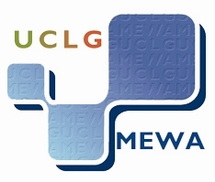



**United Cities and Local Governments**

**Middle East and West Asia Section**

**UCLG-MEWA**

**COUNCIL AND EXECUTIVE BUREAU JOINT MEETING**

**Konya/TURKEY**

**19-20 December 2013**

**DRAFT AGENDA**

1. Opening of the meeting.
2. Adoption of the Agenda.
3. Presentation of the **Progress Report** on the activities and developments since the UCLG-MEWA Congress held on 10-11 April 2013.
4. Reviewing and adoption of the **Financial Report** for 2013, prepared by the UCLG-MEWA Treasurer and the Financial Management Committee
5. Presentation and Adoption of UCLG-MEWA **Ombudsman Report**.
6. Reviewing and adoption of UCLG-MEWA 2014 draft **Program of Activities.**
7. Reviewing and adoption of UCLG-MEWA 2014 draft **Budget.**
8. Reviewing and deciding on the new applications for membership and the status of members that failed to fulfill other conditions of membership according to UCLG-MEWA Constitution.
9. Deciding upon the publisment of the UCLG-MEWA Magazine **“Newsletter”** to be published quarterlyandthe appointment of the responsible people to handle formal permissions and legal actions.
10. Reviewing and deciding on the repeal of the UCLG-MEWA Rules of Procedure and giving mandate to the Secretary General for the new Regulations on Application corcerning the affairs of Secretariat General, to be prepared.
11. Deciding upon the date, venue and the host city of the next meeting of UCLG-MEWA Executive Bureau and Council
12. Reviewing and deciding the issues raised by members.
13. Other issues.