
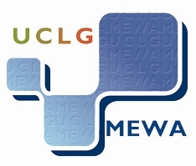

Tehran Municipality

UCLG-MEWA CONGRESS
EXECUTIVE BUREAU, COUNCIL AND GENERAL ASSEMBLY JOINT MEETING
10-11 April 2013, TEHRAN, IRAN

PRESENTATION REQUEST FORM

Name ___________________________________________________________________________

Title ____________________________________________________________________________

Municipality/Local Authority _________________________________________________________

Phone No._______________ Fax No.________________ E-mail _________________________

PRESENTATION REQUEST:

YES ➔ I would like to make a presentation/speech at the session on the “Sustainable Urban Energy”
YES ➔ I would like to make a presentation/speech at the session on the “Strengthening Urban Life Against Crises’’

Please note that a presentation/speech should not exceed a duration of 15 minutes.
An abstract should be sent to UCLG-MEWA Secretariat by e-mail by 29 March 2013.

MATERIAL REQUESTS:

I would need:
a laptop computer with projection facilities: YES
a flipchart: YES
an overhead projector: YES

Other (please specify):…………………………………………………………………………………………………………………………………………

PLEASE COMPLETE THIS PRESENTATION REQUEST FORM AND FAX OR E-MAIL IT TO:

UCLG-MEWA SECRETARIAT GENERAL – ISTANBUL (Ms. Gamze KILIÇ)
FAX: +90 212 513 44 87 - Tel: +90 212 511 10 10 - e-mail: g.kilic@uclg-mewa.org

